**DLD LAB TASK**

**Q 2(a):**

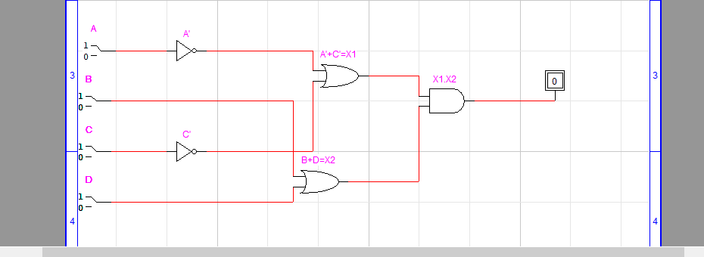

**Coloured are inputs:**

|  |  |  |  |  |  |  |  |  |  |
| --- | --- | --- | --- | --- | --- | --- | --- | --- | --- |
| **A** | **A’** | **C** | **C’** | **A’+C’** | **X1** | **B+D** | **X2** | **X1.X2** | **OUTPUT** |
| **0** | 1 | **0** | 1 | 0+1 | 1 | **0+0** | 0 | 1.0 | 0 |
| **0** | 1 | **0** | 1 | 0+1 | 1 | **0+1** | 1 | 1.1 | 1 |
| **0** | 1 | **1** | 0 | 1+0 | 1 | **0+0** | 0 | 1.0 | 0 |
| **0** | 1 | **1** | 0 | 1+0 | 1 | **0+1** | 1 | 1.1 | 1 |
| **0** | 1 | **0** | 1 | 0+1 | 1 | **1+0** | 1 | 1.1 | 1 |
| **0** | 1 | **0** | 1 | 0+1 | 1 | **1+1** | 1 | 1.1 | 1 |
| **0** | 1 | **1** | 0 | 1+0 | 1 | **1+0** | 1 | 1.1 | 1 |
| **0** | 1 | **1** | 0 | 1+0 | 1 | **1+1** | 1 | 1.1 | 1 |
| **1** | 0 | **0** | 1 | 0+1 | 1 | **0+0** | 0 | 1.0 | 0 |
| **1** | 0 | **0** | 1 | 0+1 | 1 | **0+1** | 1 | 1.1 | 1 |
| **1** | 0 | **1** | 0 | 0+0 | 0 | **0+0** | 0 | 0.0 | 0 |
| **1** | 0 | **1** | 0 | 0+0 | 0 | **0+1** | 1 | 0.1 | 0 |
| **1** | 0 | **0** | 1 | 0+1 | 1 | **1+0** | 1 | 1.1 | 1 |
| **1** | 0 | **0** | 1 | 0+1 | 1 | **1+1** | 1 | 1.1 | 1 |
| **1** | 0 | **1** | 0 | 0+0 | 0 | **1+0** | 1 | 0.1 | 0 |
| **1** | 0 | **1** | 0 | 0+0 | 0 | **1+1** | 1 | 0.1 | 0 |

**Q 2(b):**

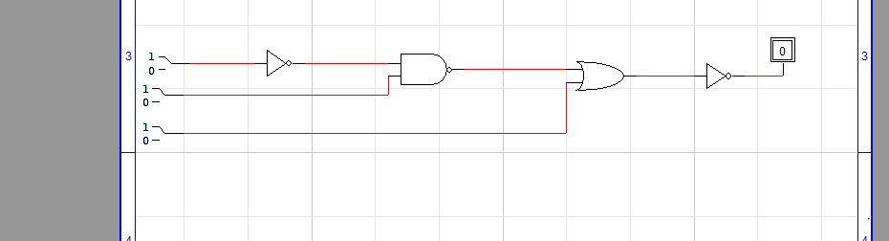

|  |  |  |  |  |  |  |  |  |
| --- | --- | --- | --- | --- | --- | --- | --- | --- |
| **A** | **A’** | **A’.B** | **X1** | **X1’** | **X1’+C** | **X2** | **X2’** | **OUTPUT** |
| **0** | 1 | 1.**0** | 0 | 1 | 1+**0** | 1 | 0 | 0 |
| **0** | 1 | 1.**0** | 0 | 1 | 1+**1** | 1 | 0 | 0 |
| **0** | 1 | 1.**1** | 1 | 0 | 0+**0** | 0 | 1 | 1 |
| **0** | 1 | 1.**1** | 1 | 0 | 0+**1** | 1 | 0 | 0 |
| **1** | 0 | 0.**0** | 0 | 1 | 1+**0** | 1 | 0 | 0 |
| **1** | 0 | 0.**0** | 0 | 1 | 1+**1** | 1 | 0 | 0 |
| **1** | 0 | 0.**1** | 0 | 1 | 1+**0** | 1 | 0 | 0 |
| **1** | 0 | 0.**1** | 0 | 1 | 1+**0** | 1 | 0 | 0 |

**Q 3(A):**

**(A+B)(B+C)**

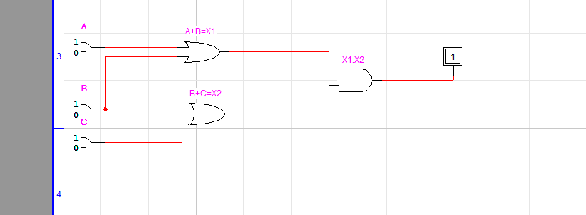

|  |  |  |  |  |  |  |  |
| --- | --- | --- | --- | --- | --- | --- | --- |
| **A** | **B** | **A+B** | **X1** | **B+C** | **X2** | **X1.X2** | **OUTPUT** |
| **0** | **0** | 0+0 | 0 | **0+0** | 0 | 0.0 | 0 |
| **0** | **0** | 0+0 | 0 | **0+1** | 1 | 0.1 | 0 |
| **0** | **1** | 0+1 | 1 | **1+0** | 1 | 1.1 | 1 |
| **0** | **1** | 0+1 | 1 | **1+1** | 1 | 1.1 | 1 |
| **1** | **0** | 1+0 | 1 | **0+0** | 0 | 1.0 | 0 |
| **1** | **0** | 1+0 | 1 | **0+1** | 1 | 1.1 | 1 |
| **1** | **1** | 1+1 | 1 | **1+0** | 1 | 1.1 | 1 |
| **1** | **0** | 1+0 | 1 | **1+1** | 1 | 1.1 | 1 |

**Q 3(B):**

**((A+B’C)(A+BC))’**

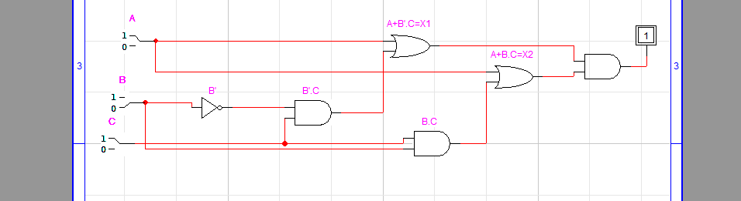

|  |  |  |  |  |  |  |  |  |  |
| --- | --- | --- | --- | --- | --- | --- | --- | --- | --- |
| **A** | **B** | **B’** | **B’.C** | **A+B’.C** | **X1** | **A+B.C** | **X2** | **X1.X2** | **OUTPUT** |
| **0** | **0** | **1** | **1.0** | **0+0** | **0** | **0+0** | **0** | **0.0** | **0** |
| **0** | **0** | **1** | **1.1** | **0+1** | **1** | **0+0** | **0** | **1.0** | **0** |
| **0** | **1** | **0** | **0.0** | **0+0** | **0** | **0+0** | **0** | **0.0** | **0** |
| **0** | **1** | **0** | **0.1** | **0+0** | **0** | **0+1** | **1** | **0.1** | **0** |
| **1** | **0** | **1** | **1.0** | **1+0** | **1** | **1+0** | **1** | **1.1** | **1** |
| **1** | **0** | **1** | **1.1** | **1+1** | **1** | **1+0** | **1** | **1.1** | **1** |
| **1** | **1** | **0** | **0.0** | **1+0** | **1** | **1+0** | **1** | **1.1** | **1** |
| **1** | **1** | **0** | **0.1** | **1+0** | **1** | **1+1** | **1** | **1.1** | **1** |

**Q 3(C):**

**(A’+BC)’**

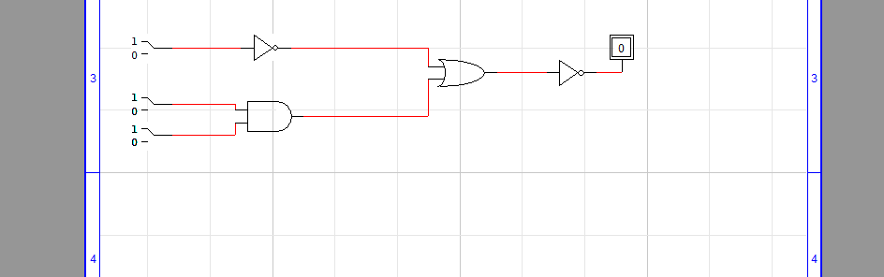

|  |  |  |  |  |  |  |  |  |
| --- | --- | --- | --- | --- | --- | --- | --- | --- |
| **A** | **A’** | **B** | **C** | **B.C** | **A’+B.C** | **X1** | **X1’** | **OUTPUT** |
| **0** | **1** | **0** | **0** | **0** | **1+0** | **1** | **0** | **0** |
| **0** | **1** | **0** | **1** | **0** | **1+0** | **1** | **0** | **0** |
| **0** | **1** | **1** | **0** | **0** | **1+0** | **1** | **0** | **0** |
| **0** | **1** | **1** | **1** | **1** | **1+1** | **1** | **0** | **0** |
| **1** | **0** | **0** | **0** | **0** | **0+0** | **0** | **1** | **1** |
| **1** | **0** | **0** | **1** | **0** | **0+0** | **0** | **1** | **1** |
| **1** | **0** | **1** | **0** | **0** | **0+0** | **0** | **1** | **1** |
| **1** | **0** | **1** | **1** | **1** | **0+1** | **1** | **0** | **0** |

**Q 5:**

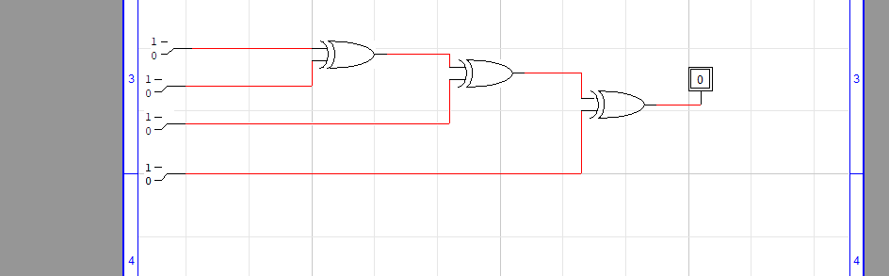

**ODD Parity:**

|  |  |  |  |  |  |  |
| --- | --- | --- | --- | --- | --- | --- |
| **A** | **B** | **C** | **D** | **X1** | **X2** | **OUTPUT** |
| **0** | **1** | **0** | **0** | **1** | **0** | **1** |
| **0** | **0** | **0** | **1** | **0** | **1** | **1** |
| **1** | **0** | **0** | **0** | **1** | **0** | **1** |

**EVEN Parity:**

|  |  |  |  |  |  |  |
| --- | --- | --- | --- | --- | --- | --- |
| **A** | **B** | **C** | **D** | **X1** | **X2** | **OUTPUT** |
| **1** | **0** | **1** | **0** | **1** | **1** | **0** |
| **0** | **1** | **1** | **0** | **1** | **1** | **0** |
| **0** | **0** | **1** | **1** | **1** | **1** | **0** |